BASIC PYTHON
- Split this string

Code:
s = "Hi there Sam!"
print(s.split())

Output:

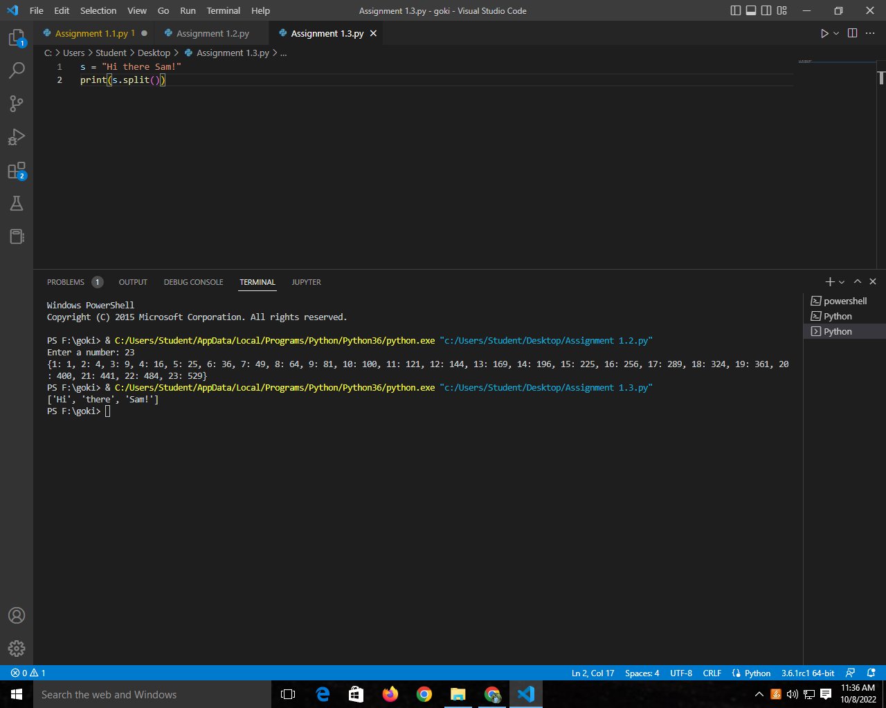

Use .format() to print the following string.Output should be: The diameter of Earth is 12742 kilometers.

Code:
planet = "Earth"
diameter = 12742
print("The diameter of {} is {} kilometers.".format(planet,diameter))

Output:

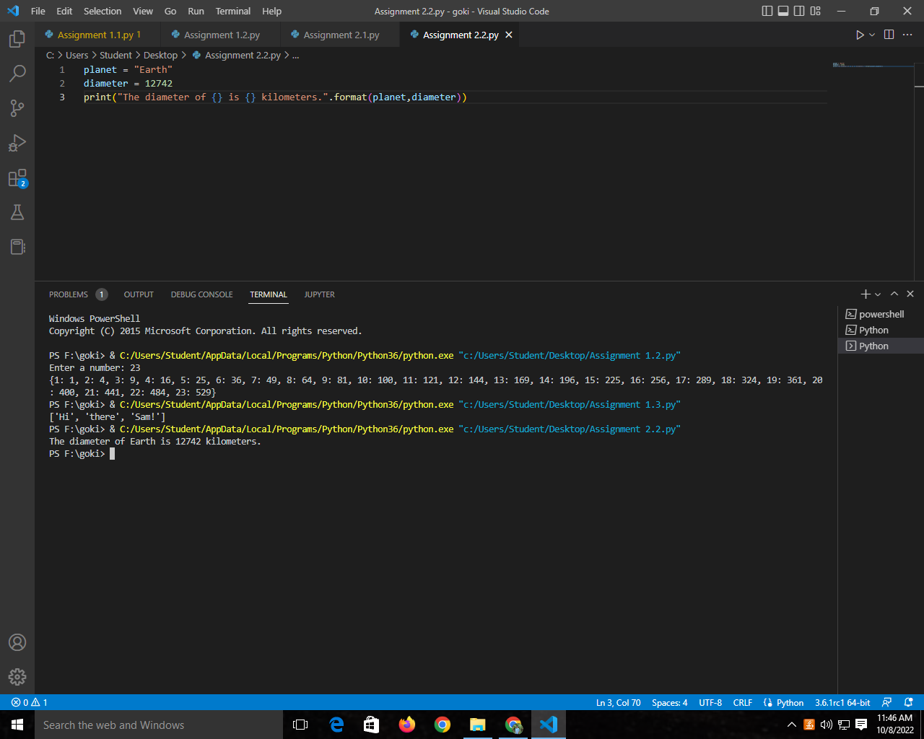

In this nest dictionary grab the word "hello"

Code:
d = {'k1':[1,2,3,{'tricky':['oh','man','inception',{'target':[1,2,3,'hello']}]}]}
d['k1'][3]['tricky'][3]['target'][3]

Output:

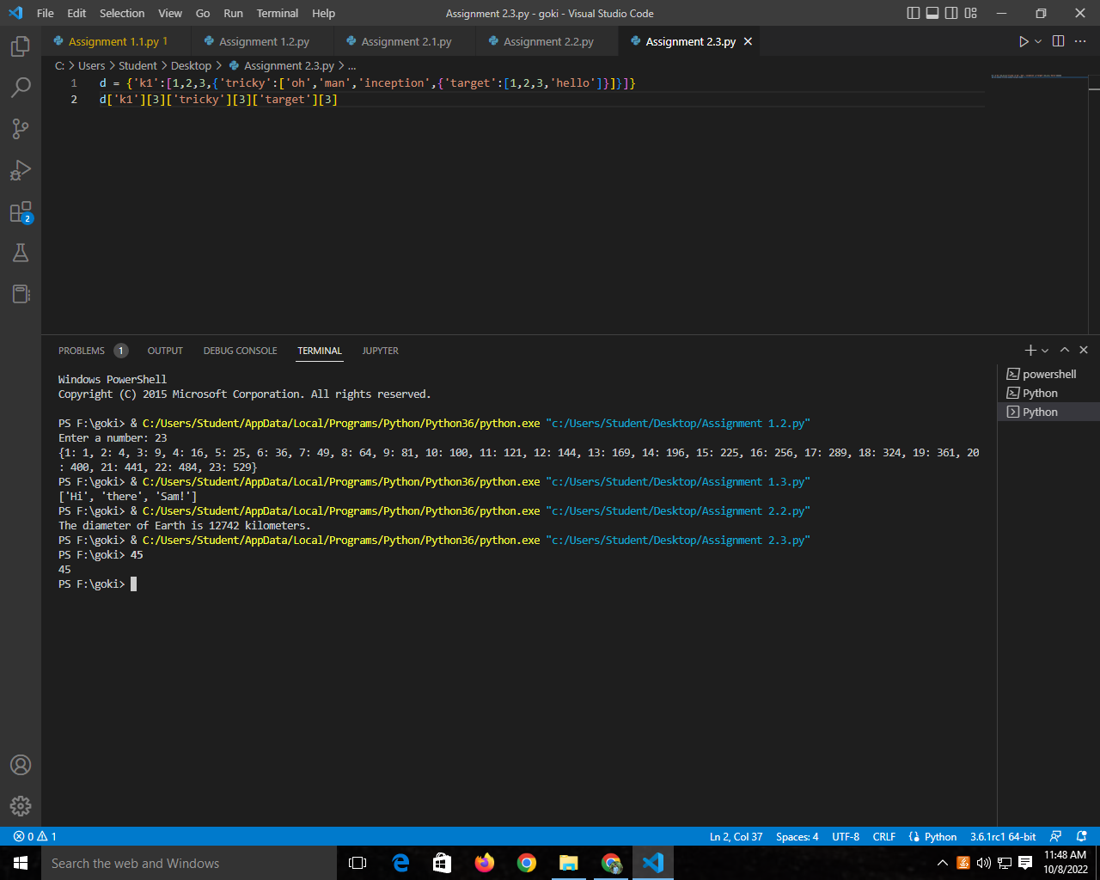

4.1 Create an array of 10 zeros?

Code:
a0=[0]*10
print(a0)

Output:

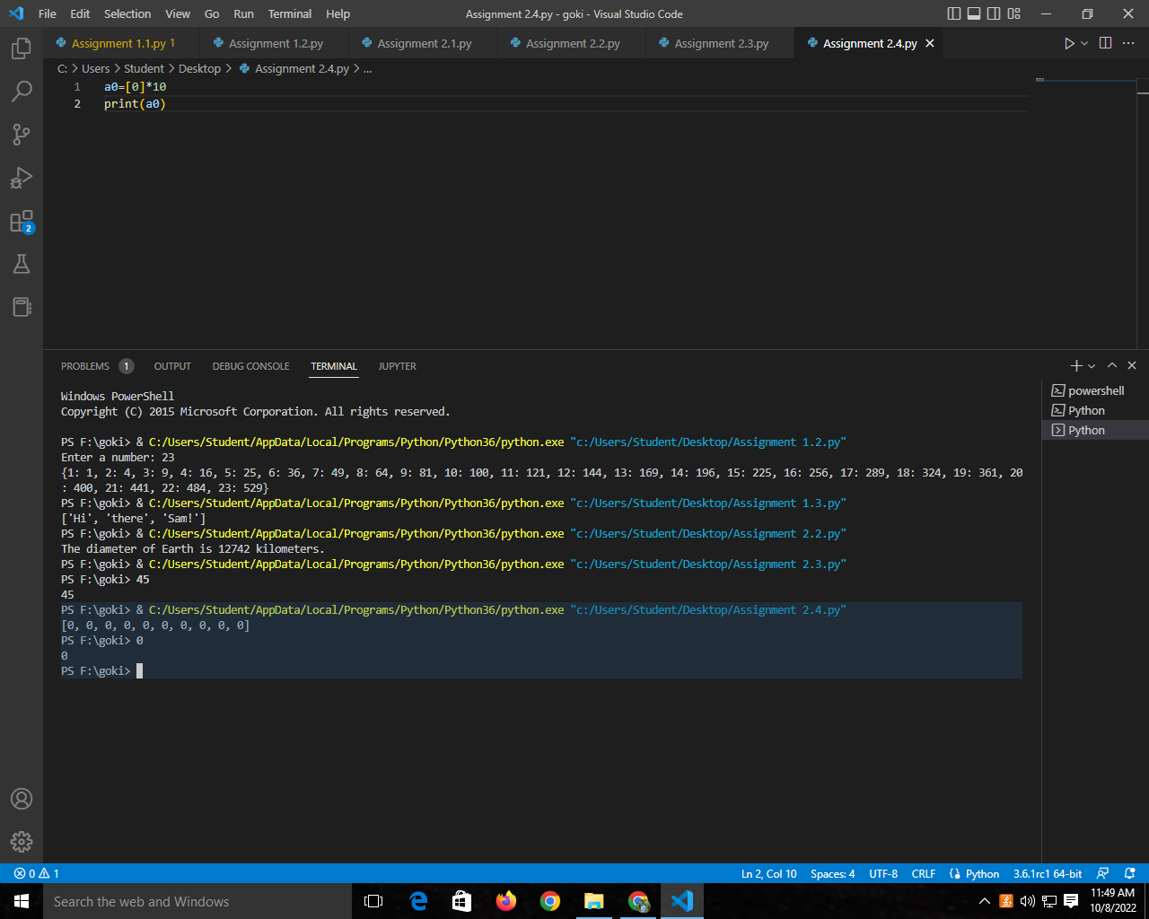

4.2 Create an array of 10 fives?

Code:
a5=[5]*10
print(a5)

Output:

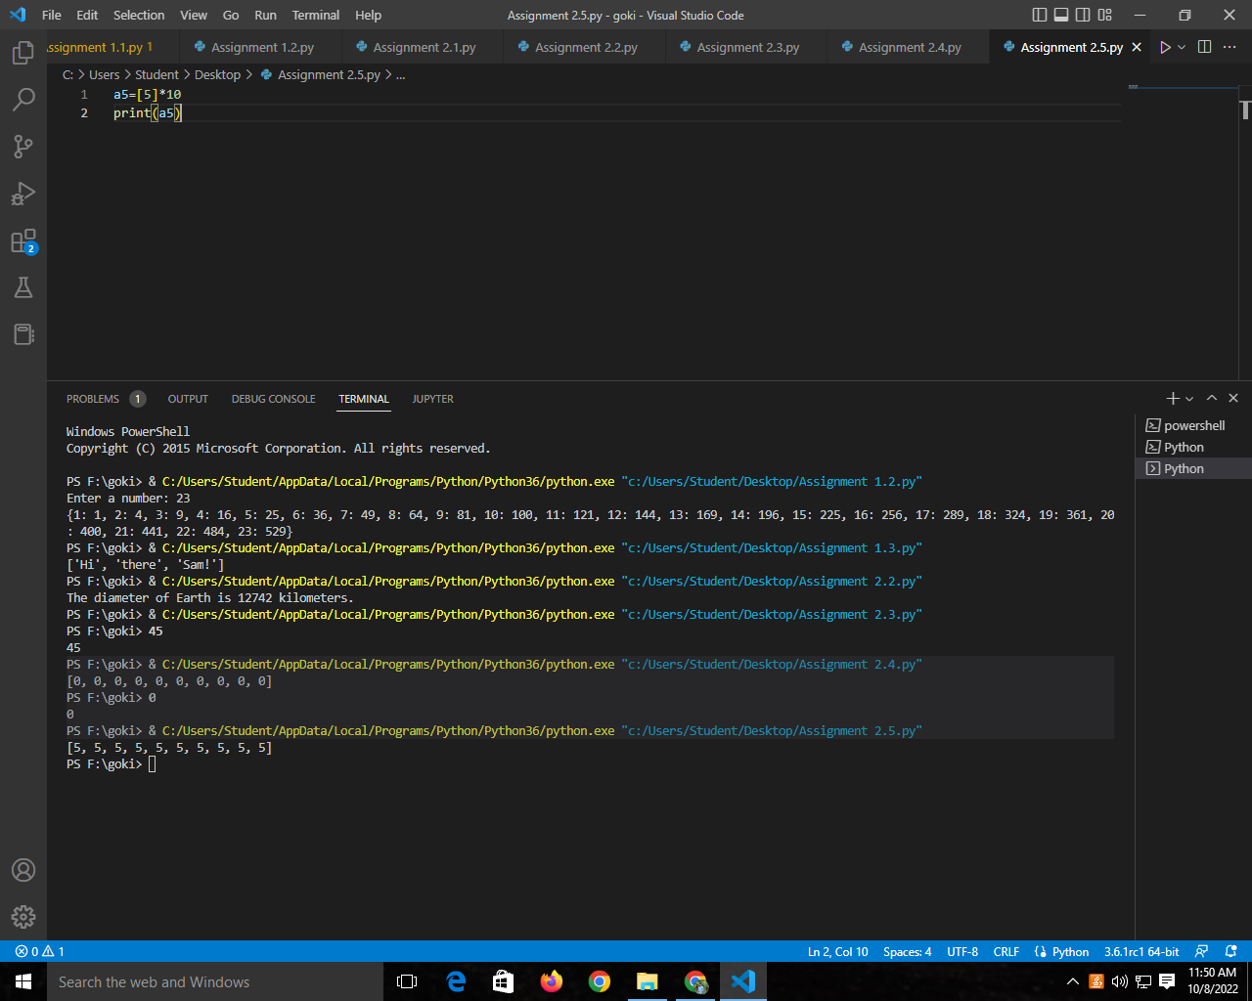

Create an array of all the even integers from 20 to 35

Code:
arr=np.arange(20,35,2)
print(arr)

Output:

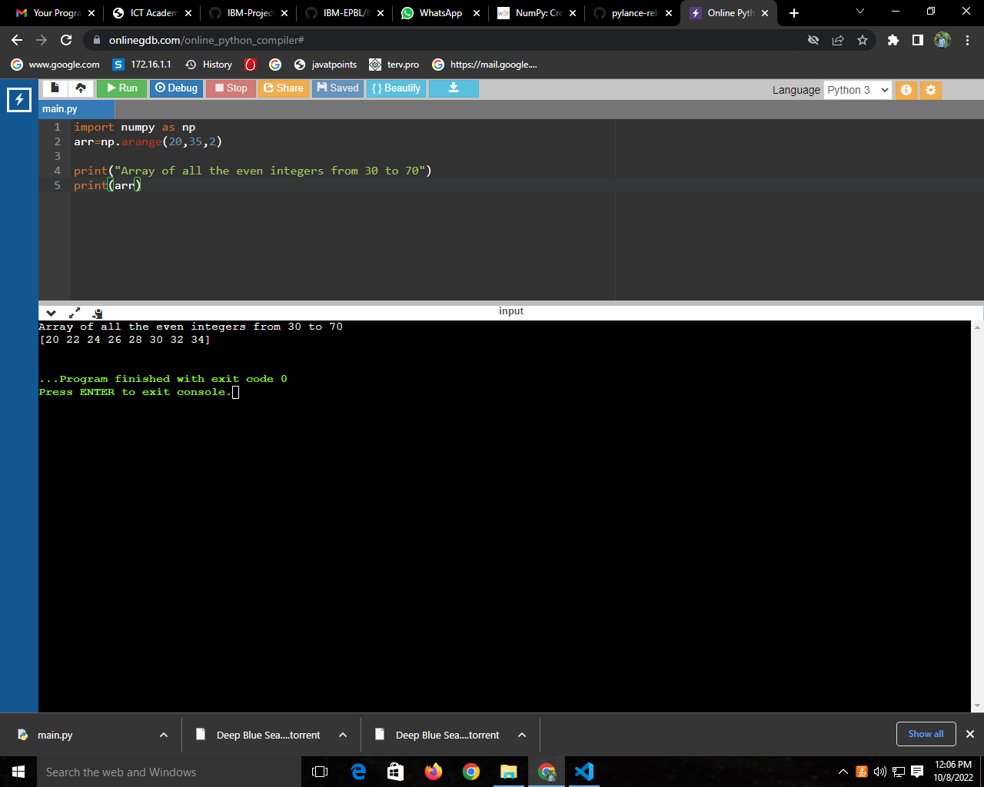

Create a 3x3 matrix with values ranging from 0 to 8

Code:
x = np.arange(0,9).reshape((3,3))
print(x)

Output:

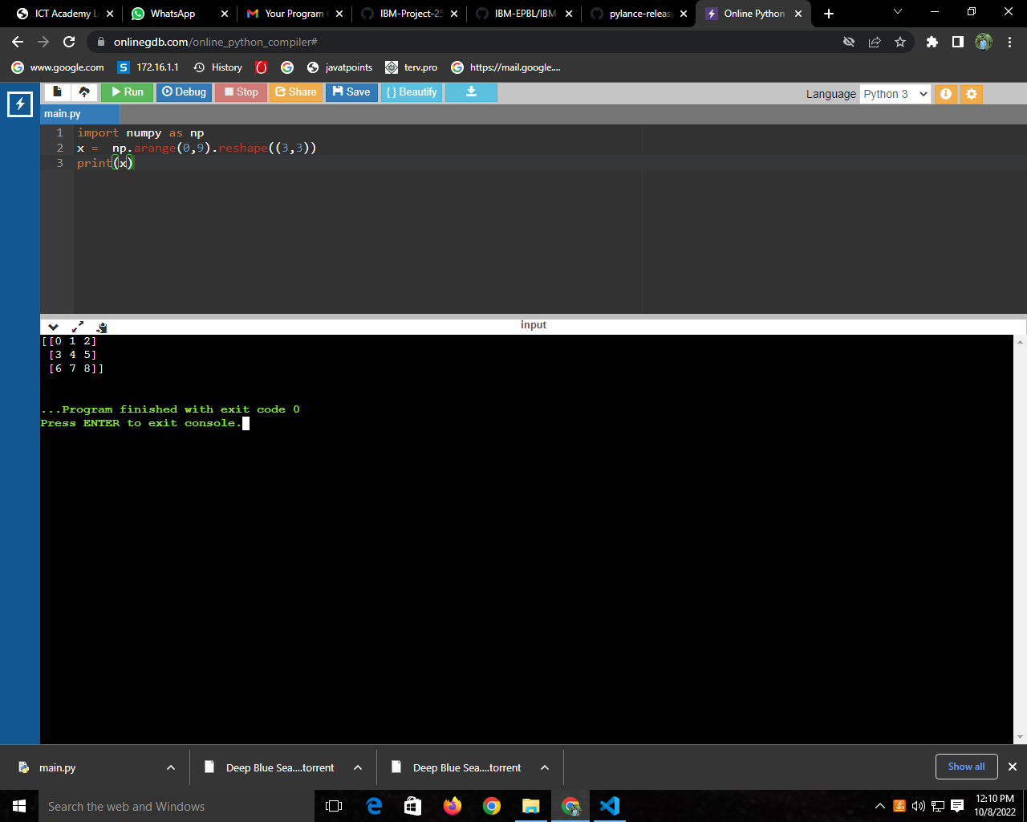

Concatenate a and b

Code:
a = np.array([[1, 2, 3]])
b = np.array([[4, 5, 6]])
np.concatenate((a,b),axis=0)

Output:

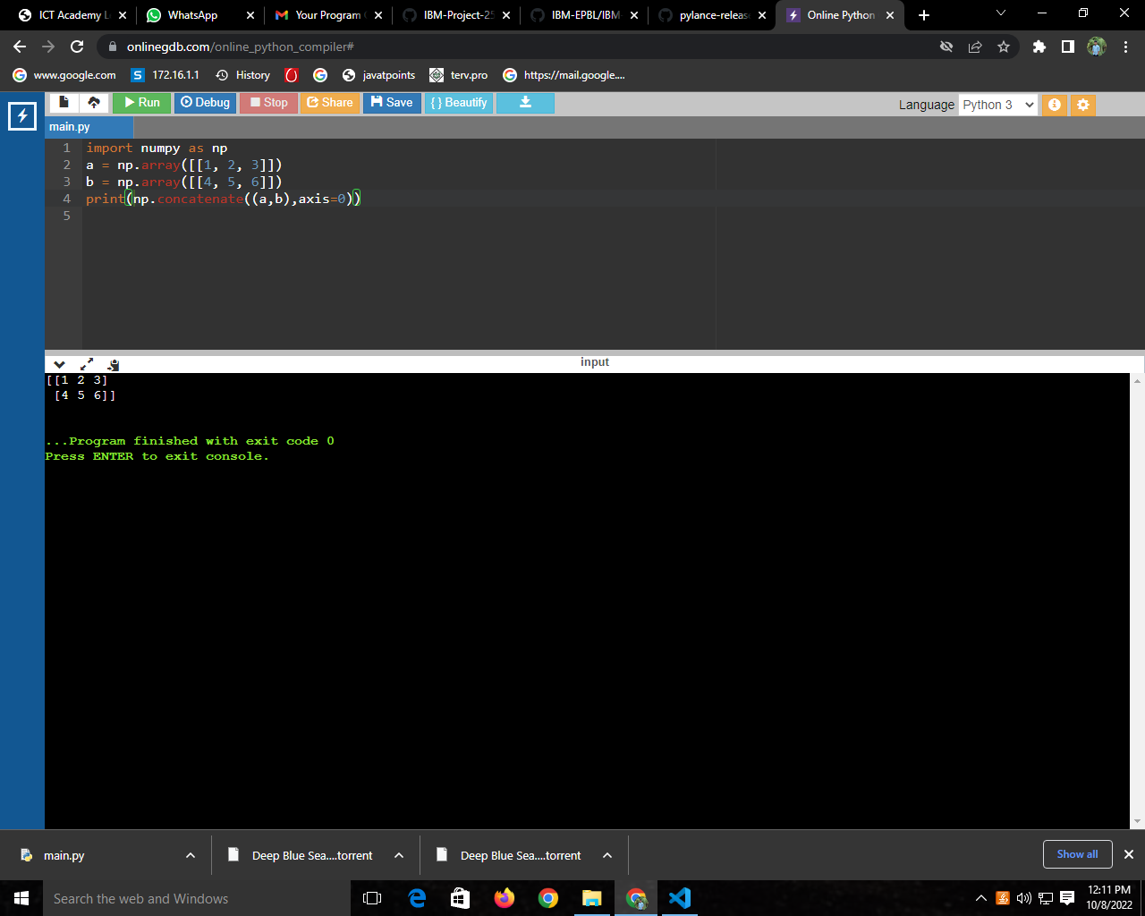

Create a dataframe with 3 rows and 2 columns

Code:
import pandas as pd
data = [['tom', 10], ['nick', 15], ['juli', 14]]
df = pd.DataFrame(data, columns=['Name', 'Age'])
Print(df)

Output:

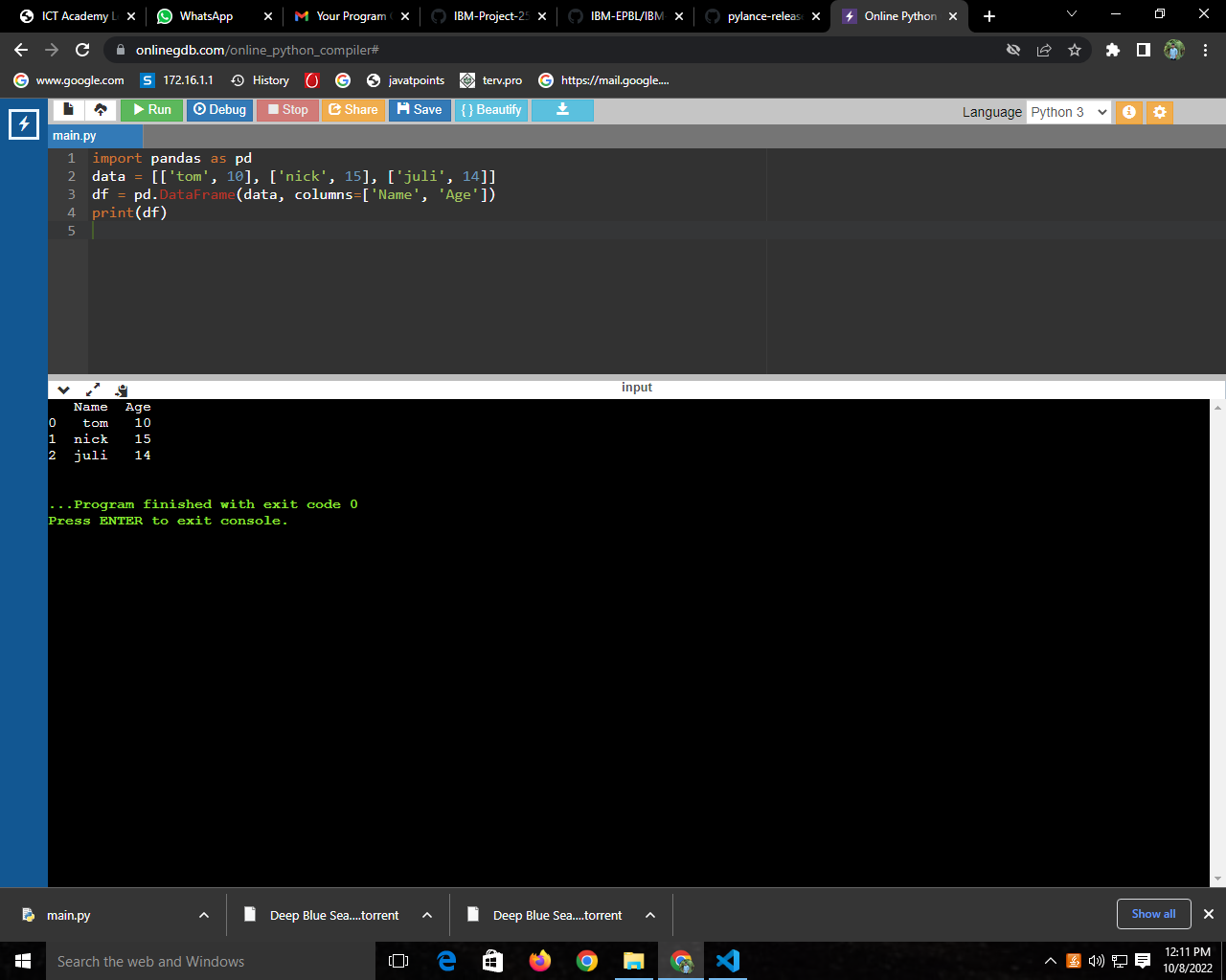

Generate the series of dates from 1st Jan, 2023 to 10th Feb, 2023

Code:
date = pd.date_range(start ='1-1-2023',
end ='02-10-2023')
for val in date:
print(val)

Output:

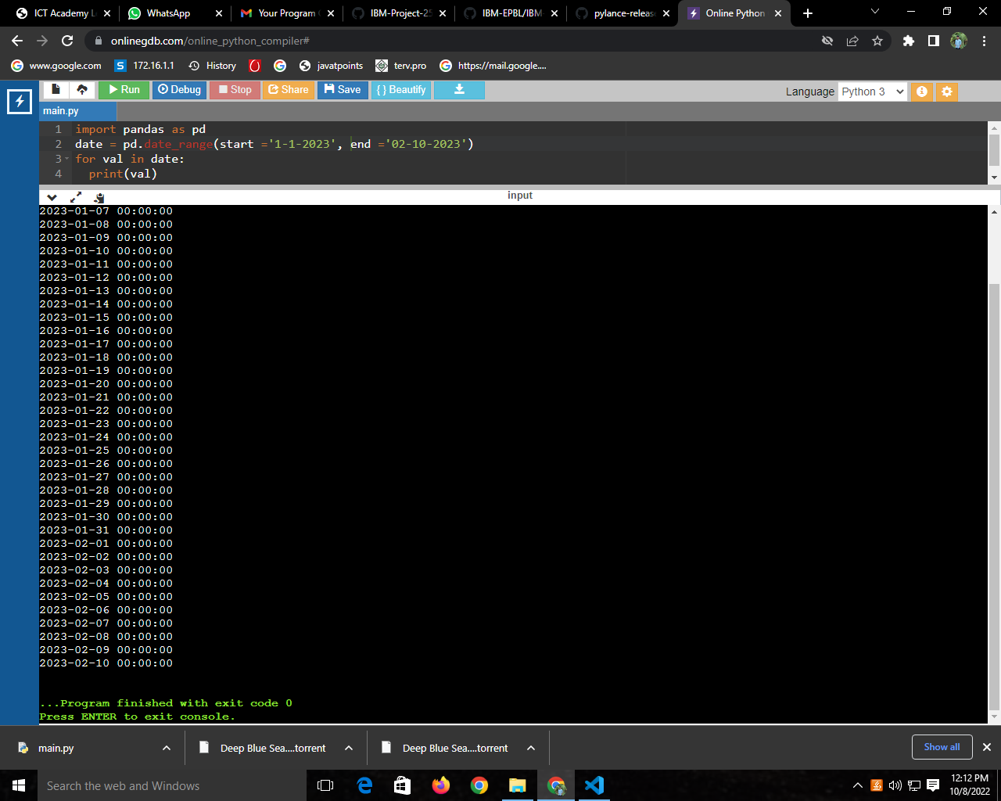

Create 2D list to DataFrame lists = [[1, 'aaa', 22], [2, 'bbb', 25], [3, 'ccc', 24]]

Code:
lists = [[1, 'aaa', 22], [2, 'bbb', 25], [3, 'ccc', 24]]
df = pd.DataFrame(lists, columns =['Rollno','Name', 'Age'])
print(df)

Output:

